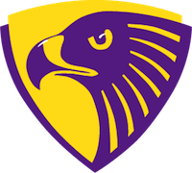
Hornsby Middle School
Annual Hawk Hike
Friday, November 19th

Student Name: Grade:

Homeroom Teacher:

Pledge/Donation
Sponsor’s Name: Amount $$

Total Pledges Collected: $

Pledges may be collected by cash or check (payable to “HMS PTSA”) or
online at our website at http://www.hornsbyptsa.org/hornsby-hawk-donation.html

*To qualify for a free Menchies Frozen Yogurt event at school in December students need to collect at least $25 in pledges or donations. All Pledge money due Friday, November 19th.*

